**LAB01 Test-bed setting[STEP 1-5]**

|  |  |
| --- | --- |
| Class | CT313H |
| Student ID | B2111933 |
| Name | Truong Dang Truc Lam |
| Email address | lamb2111933@student.ctu.edu.vn |
| Submitting date | 12/08/2024 |

**[STEP 1] Virtual Machine installation & status check**

**Which VM OS type will you use for your exercise? (screen shot)**

|  |  |  |  |  |  |
| --- | --- | --- | --- | --- | --- |
|  | Real host | VM OS | | | |
|  | Windows | Ubuntu | Centos | Kali | Windows |
| VMware |  |  |  |  |  |
| VirtualBox |  | **x** |  |  |  |

* Mainly we will use Ubuntu

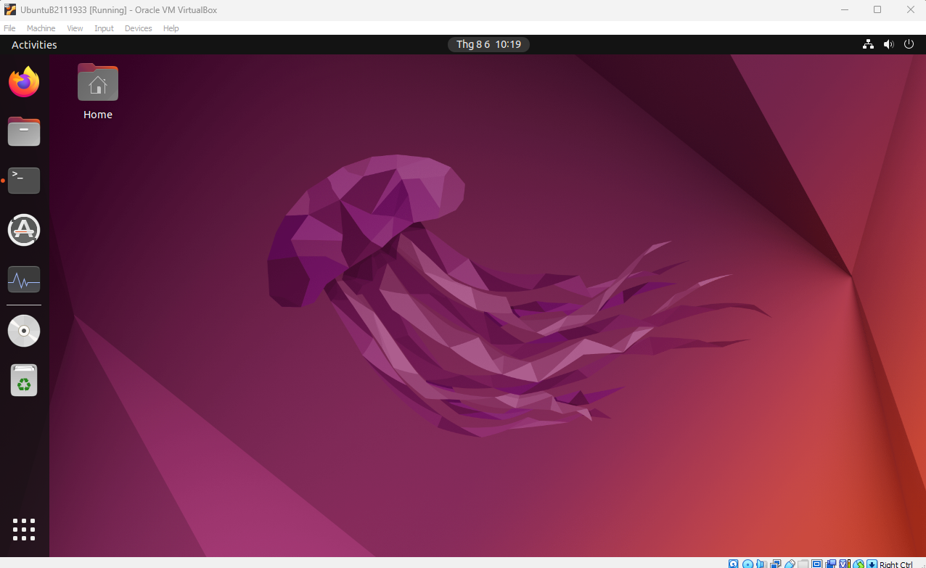

I use **Ubuntu 22.04** for the target VM

1. **Check your Virtual Machine name** Ubuntu **[$ uname –a]**

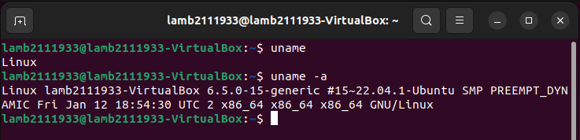

My Virtual Machine name is **Ubuntu (Linux)**

1. **Check your guest OS name** Ubuntu**: GNU/Linux [$ uname –o]**

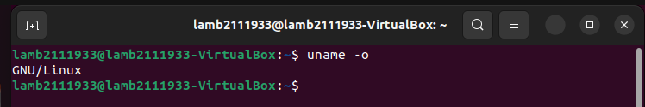

OS name is **GNU/Linux**

1. **What kind of linux for Virtual Machine?** Ubuntu **[$ uname –r]**

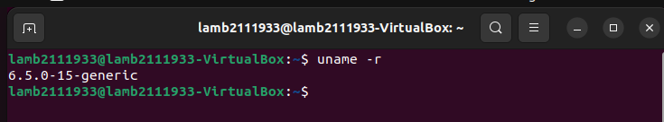

My Linux kernel vesion is **6.5.0-15-generic**

**[STEP 2] Define the addresses of test-bed (screen shot)**

|  |  |  |
| --- | --- | --- |
| **Role** | **SENDER** | **TARGET** |
| Tester | Victim |
| IP address | Student’s real IP  Student’s VM IP  (Kali, Ubuntu, Centos each) | * real system :CTU,CICT URL, IP * student’s VM IP   (Kali, Ubuntu, Centos each)   * loopback address * neighbor PC IP in class |
| HW | Class terminal | Class terminal |
| NW device | Hub, router, GW |  |
| OS | Real host(window)  VM(Kali,Ubuntu,Centos) | Real host(window)  VM(Kali,Ubuntu,Centos) |
| SW |  |  |

1. Check host IP[Window]

CMD ipconfig/all

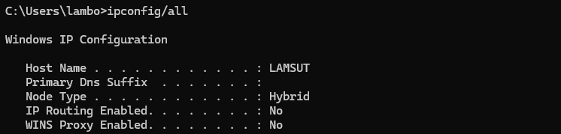

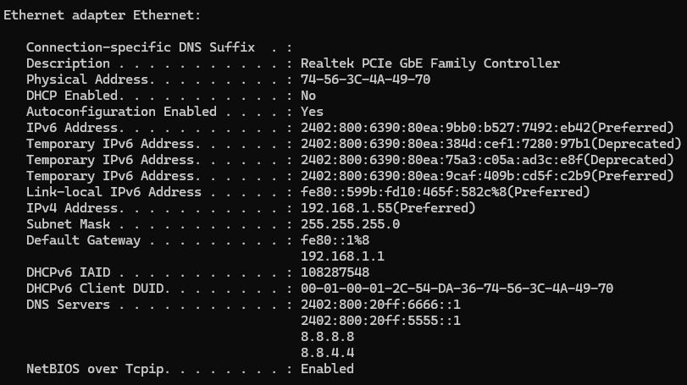

My host IP is **192.168.1.55**

1. Check VM IP [Linux]

$ sudo apt install net-tools

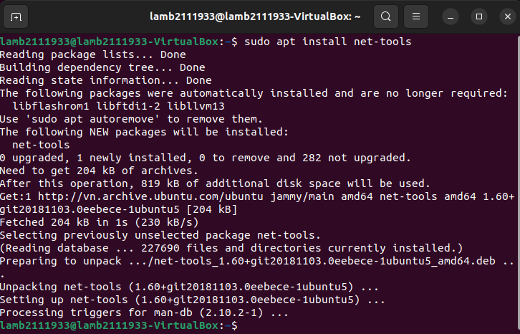

Install necessary packages

$ ifconfig

* Ubuntu

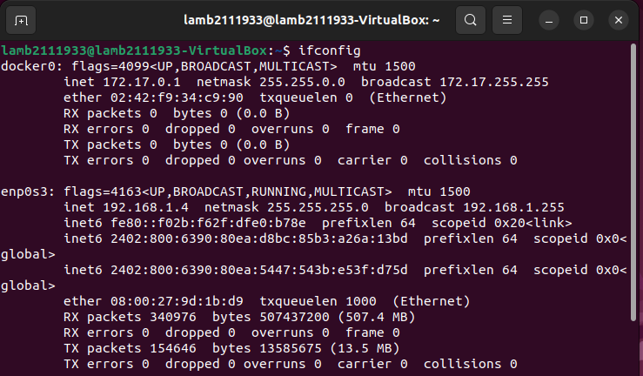

IP of the VM is **192.168.1.4** (enp0s3)

* Centos
* Kali

1. Define target IP [Windows:CMD nslookup URL]

* CTU IP

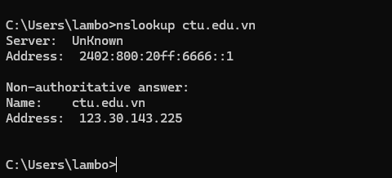

IP address of CTU website is **123.30.143.225**

* CICT IP

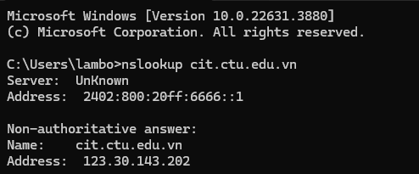

IP address of CICT website is **123.30.143.202**

* loopback address [Windows]

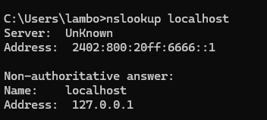

The loopback address of Host [Windows] is **127.0.0.1** (localhost)

* neighbor PC IP in class [Windows] => your classmate IP

Sorry but I did this lab at home

**[STEP3] Check packet exchanging status between sender and target command prompt (snap shot)**

1. Ping from Host[Windows] to Virtual Machine [Linux] OS

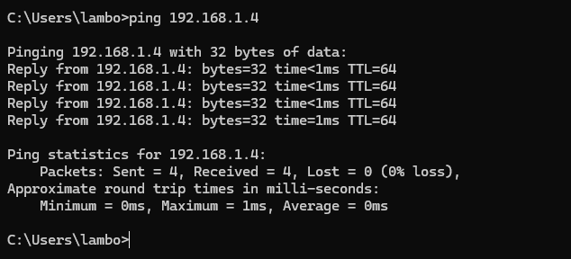

Ping from Host (**192.168.1.55**) to Virtual Machine (**192.168.1.4**)

1. Check TTL value with Ping

When ping from Host to VM, TTL value is 64

1. Ping from Virtual Machine OS [Linux] to Host [Windows]

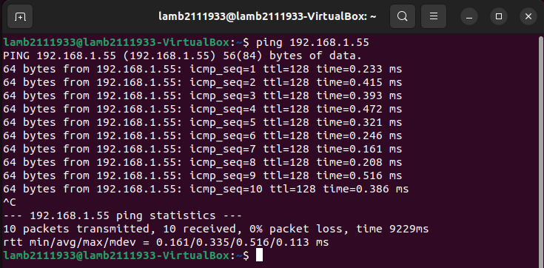

Ping from Virtual Machine (**192.168.1.4**) to Host (**192.168.1.55**)

1. Check TTL value with Ping

When ping from VM to Host, TTL value is 128

1. Ping from Host[Windows] to loopback[Windows] of terminal

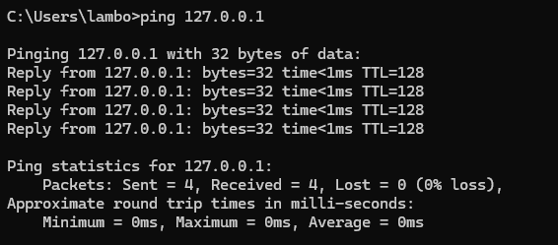

Ping from Host (**192.168.1.55**) to loopback (**127.0.0.1**)

When ping from Host to loopback, TTL value is 128

1. Explain the meaning of TTL (time to live) in Ping reply

**Explain:** Time to live (TTL) refers to the amount of time or “hops” that a packet is set to exist inside a network before being discarded by a router. This prevents packets from looping indefinitely. Most operating systems have a default initial TTL value that is used for outgoing packets. This is often 64 or 128.

* Each router a packet encounters decrements the TTL value by 1.
* If the TTL reaches 0 before the packet reaches its destination, the router discards it and sends an ICMP Time Exceeded message back to the source.

**[STEP 4] Check routing route status between sender and target (snap shot)**

1. Tracert from Host[Windows] to [Linux] and check how many nodes were connected for packet transmission with Tracert?

Windows:CMD tecert

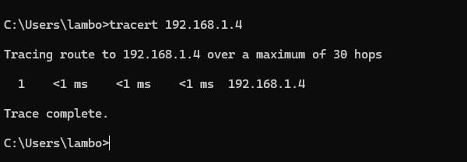

There is **1** node was connected for packet transmission with Tracert from Host to VM

1. Traceroute from Virtual OS [Linux] to Host [Windows] and check how many nodes were connected for packet transmission with Traceroute?

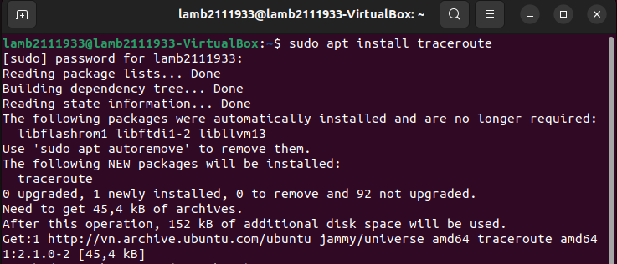

Install necessary packages

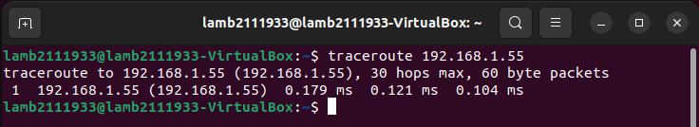

There is **1** node was connected for packet transmission with Traceroute   
(similar to Tracert in Windows) from VM to Host

1. Tracert from Host [Windows] to loopback of terminal [Windows:CMD]

Windows:CMD tecert to loopback

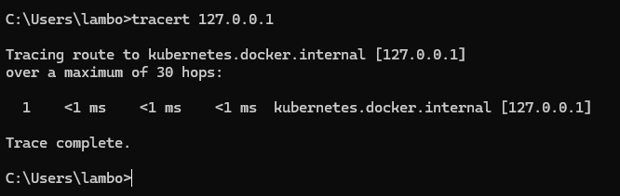

There is **1** node was connected for packet transmission with Tracert from Host to loopback

It’s 14 nodes.  
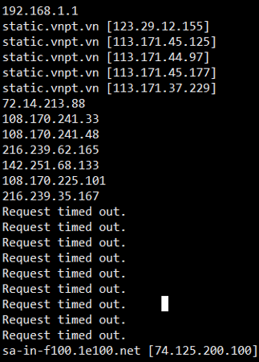

**[STEP 5] Advanced Ping test [Linux]:**

1. Send 5 packets to facebook.com, from Windows

ping -c 5 facebook.com.

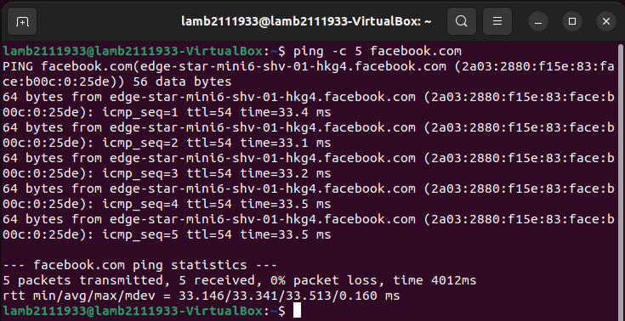

Ping with **-c** option will specify the number of echo requests to send (5 in this case)

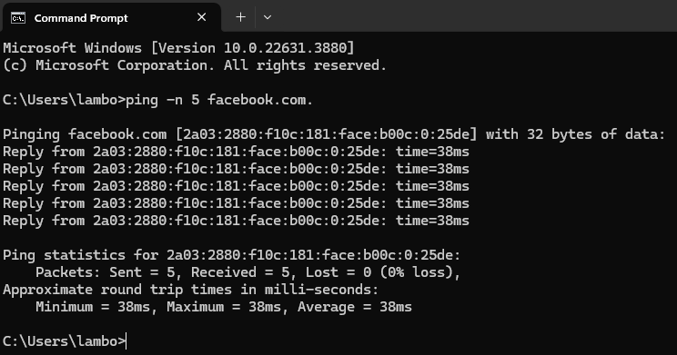

In Windows, there is no **-c** option, so I use **ping -n 5 facebook.com** instead

1. ping Facebook for 10 seconds from Ubuntu and then display the results

ping -w 10 facebook.com.

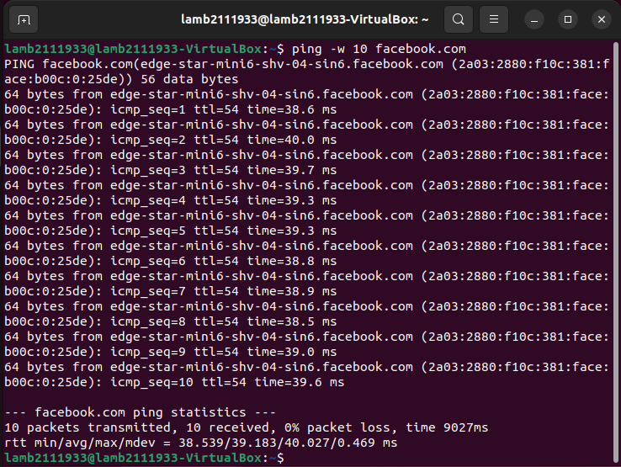

The interval between packets is **1 second**, so there are still **10 packets in 10 seconds**

[Change the interval between packets]

1. To increase the wait to 3 seconds between packets in your ping to Facebook, you'd use from Ubuntu

ping -i 3 facebook.com.

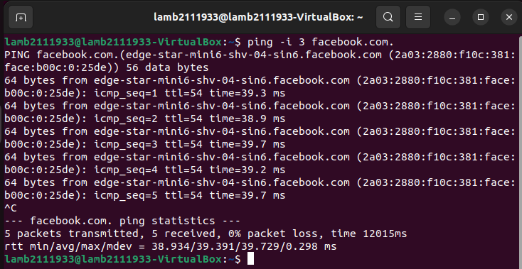

To increase the wait to 3 seconds between packets in your ping to Facebook, use **-i** option

1. To decrease the wait to half of one second, from Ubuntu

ping -i 0.5 facebook.com.

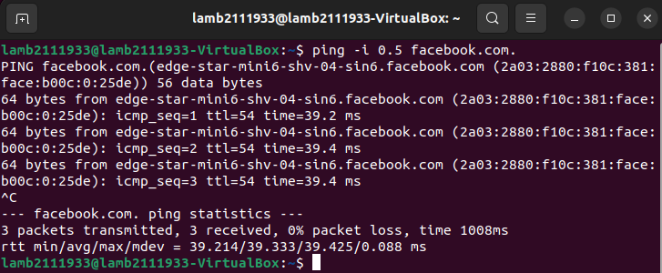

Decrease the wait to half of one second, the packets were transferred really fast

[Change the size of your packets].

1. By default, ping packets are 56 bytes, To send 1000 bytes instead of the default, you'd use

ping -s 1000 facebook.com. from Ubuntu

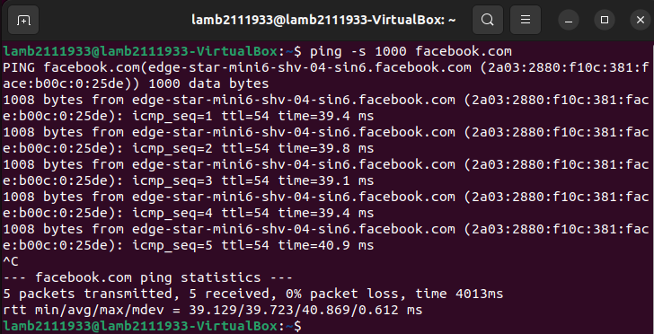

To send 1000 bytes instead of 56 bytes (default), use the **-s** option

<https://www.wikihow.com/Ping-in-Linux#/Image:Ping-in-Linux-Step-2-Version-3.jpg>

<https://monovm.com/post/33/how-to-ping-in-centos>

<https://m.wikihow.com/Ping-in-Linux>